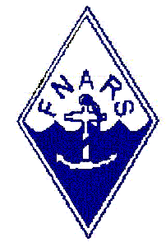
International Naval Contest 2023
From 09.12.2023 16:00 UTC to 10.12.2023 15:59 UTC

To: FNARS
Rauno M. Kekäläinen
Ostjakinkatu 5 F 22
FI 20750 Turku
Finland
e-mail: oh1wr@oh1aj.fi

Callsign: Category of participation:

Christian name: (X) A = Naval Station all band mixed mode (S.O.)

Name: (X) B = Naval Station all band CW (S.O.)

Street: (X) C = Naval Station all band SSB (S.O.)

City: (X) D = All band SWL

Zip code: (X) E = Naval Club Station (M.O.)

Country: (X) F = Non Naval Station

E-mail:

Band QSO Points Multipliers
80 m 0 0 0
40 m 0 0 0
20 m 0 0 0
15 m 0 0 0
10 m 0 0 0
_____________________________________________________
Total: 0 0 0
_____________________________________________________

Score: 0 Points x 0 Multipliers = 0 Contestpoints
______________________________________________________

I declare, having acted accordingly to the rules of the International Naval Contest.

………………….……… ………….…..…… ………………………….………
QTH Date Signature

